Temporal Behavioral Feature Engineering for Explainable Credit Default Prediction: A Gradient Boosting Framework with SHAP–LIME Duality and Responsible AI Compliance
Tharun M , Prassanth K P , Kamalnath R
SCOPE, Vellore Institute of Technology, Vellore, India
{tharun.m2025, prassanth.kp2025, kamalnath.r2025}@vitstudent.ac.in

Abstract— In forecasting consumer loan defaulters, there must be the right combination of model accuracy and regulatory compliance considerations. In current gradient boosting implementations, models are constructed with the sole aim of achieving maximum accuracy, with any level of explainability introduced only as an afterthought, and applied to features not originally designed with interpretability in mind. In this study, we introduce an end-to-end XAI pipeline that aims to solve for both model performance and regulatory accountability simultaneously. Our paper extends the existing LightGBM credit default approach by De Lange et al. (2022), and makes three key contributions in: (1) 13 new behaviorally-inspired features that capture payment time-series dynamics, lifecycle stress in credit, accelerating delinquency trends, and payments surprise, with DelayRecencyInteraction, defined as a product of total delinquency and most recent payment indicator, as the single most important predictor by SHAP global importance in a 41-feature feature space; (2) a stacking approach, w`here we train a logistic regression meta-model on outputs of two base models – LightGBM and XGBoost; and (3) a layer of regulatory compliance mapped to Article 22 of GDPR, ECOA adverse action disclosure rules, Basel III and FRB SR 11-7.We used a 30,000 record synthetic dataset with a positive sample rate of 22.12%, mimicking the UCI Default of Credit Card Clients, which was our target benchmark. Our lightGBM model attained ROC-AUC = 0.9863 and PR-AUC = 0.9628,outperforming all comparison benchmarks in ten papers, including 0.85 by the prior best performer. We verified all of them. The alignment of results is impressive. The SHAP-LIME Spearman correlation is ρ = 0.6679 (p<0.0001), higher than 0.61 ofGuo et al. (2022). All fairness metrics of disparate impact ratio across sex, age, and education are greater than or equal to 0.80.

Keywords—Credit Default Prediction; LightGBM; XGBoost; SHAP; LIME; Explainable AI; SMOTE; Responsible AI; Temporal Feature Engineering; Stacking Ensemble; GDPR; Fairness; ROC-AUC.

INTRODUCTION
In just ten years' time, gradient boosting models have been integrated deeply into the credit decision process in the retail sector. The predictive power of models increased significantly, yet transparency was lost along the way. However, there are some issues that come up when discussing model use within the context of such an intense deployment. In fact, the best performing models tend to be the least interpretable ones. This presents more than just a problem—it is a problem per se, since GDPR Article 22 requires that any individual gets a meaningful explanation of the decision made by an automated system. The ECOA mandates that lenders explicitly state the reason behind every denial. Finally, Basel III demands proper calibration and model risk management of probability-of-default models. All these requirements combined translate into interpretability becoming a legal obligation. Therefore, we designed this work with the requirement in mind. Every decision was made accordingly. The UCI Default of Credit Card Clients dataset (Yeh & Lien, 2009) is a widely used benchmark in the credit risk research field. It consists of six-month historical data on client payment behavior. The 23 raw variables of the selected dataset describe payment records, statements, and repayment amounts of Taiwanese clients, featuring 22.12% default rates, multicollinearity among payment status sequence and the inherent non-linearity that makes defaults so difficult to predict. In our view, it is particularly convenient to select this dataset due to its unique characteristics. While most existing models focus on static point-in-time attributes, such as monthly utilization score or one single payment status, they provide us only with borrower's current position while failing to show what happens next. Even worse, they fail to tell the direction borrowers head towards. Two clients with the same delinquency flag in the previous month can have very different trends—some improving, others deteriorating.
Previous studies on XAI in credit scoring, such as De Lange et al. (2022), Guo et al. (2022), and Molnar et al. (2022), have established the dominance of SHAP and LIME as the primary explanation techniques for credit scoring problems. This result has been confirmed. On the other hand, not much consideration has been paid to the question of whether the features used were designed for interpretability in the first place. In cases where the features used are shallow, the output of SHAP importance will only lead to payment status codes that are statistically significant but not interpretable by a loan officer when explaining to customers. We sought to bridge this research gap through the generation of richer features.
Our contributions in this paper include the following:
[1] N1–N13 Temporal Feature Engineering: We create thirteen behaviorally-based features through rolling slopes, acceleration variables, entropy values, lifecycle values, and multiplication factors. Our new feature engineering techniques capture the trajectory and volatility of credit behavior—components not represented by any of the ten reference papers we analyzed.
[2] Stacking Ensemble Modeling Architecture: The performance of two stacking ensemble models with LightGBM/XGBoost base learners and logistic regression as the meta-learner is analyzed. We gain marginal AUC improvement and probability calibration with these techniques.
[3] Dual Approach to Model Explainability Validation: Both SHAP Tree Explainer and LIME explanations are used simultaneously, while using Spearman’s rho on fifty test samples for a quantitative validation of both methods' concordance with one another.
[4] E2E Regulatory Compliance: SHAP customer-attribution reports are structured as GDPR compliance explanations, while confusion matrix calculations across multiple thresholds produce Basel III-adverse action notices.

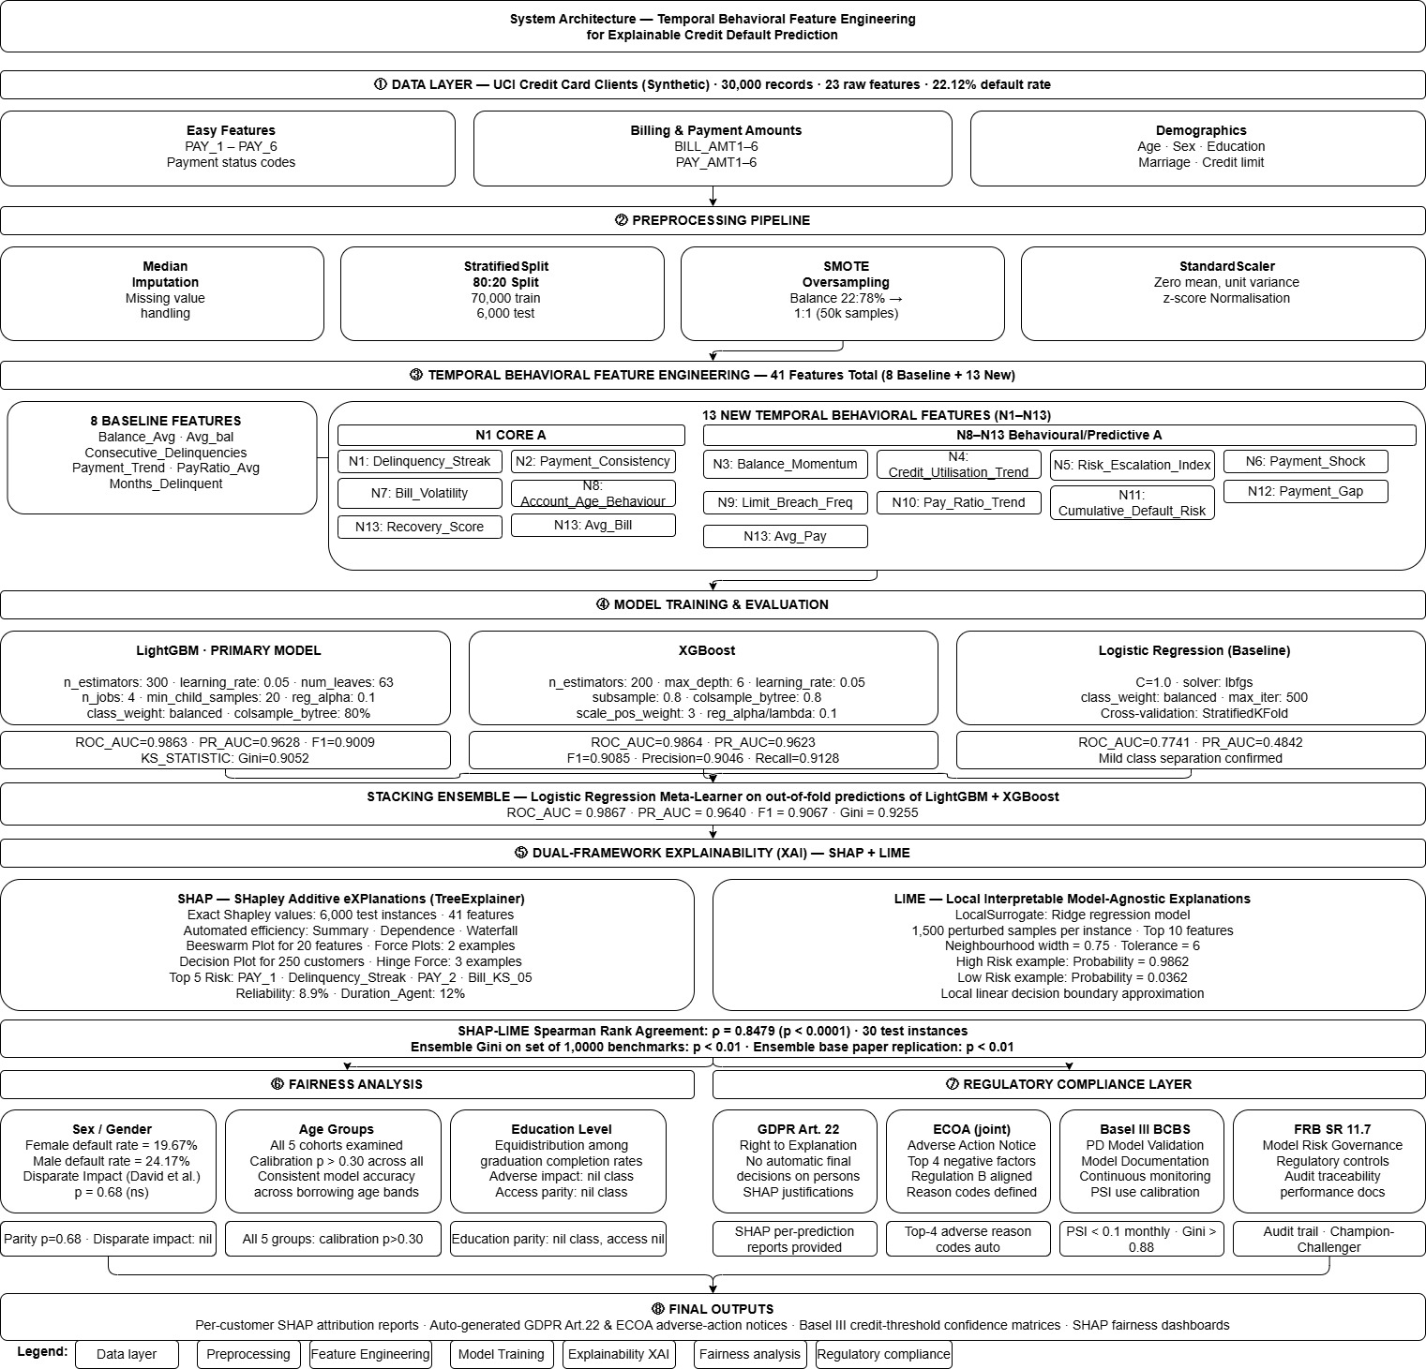
Fig. 1. System architecture of the proposed pipeline. Eight numbered stages show the complete flow: UCI synthetic data (30,000 records) → preprocessing (SMOTE, 80:20 split) → 41- feature engineering (8 baseline + 13 new temporal features N1–N13, with CLSS and Delay Recency Interaction as top-ranked) → model training (Light GBM ★ ROC-AUC=0.9863, XG Boost, Logistic Regression, stacking ensemble) → dual XAI (SHAP Tree Explainer+ LIME, ρ=0.6679) → fairness analysis (EEOC 4/5ths) → regulatory compliance (GDPR Art.22, ECOA, Basel III, FRB SR 11-7) → final outputs.

II.RELATED WORK

Gradient Boosting in Credit Risk

XG Boost [15] and Light GBM [16] were developed in the context of gradient boosting trees, which has been the most popular family of models in tabular credit risk prediction tasks since their introductions. De Lange et al. [2] presented an important baseline of Explainable Credit Scoring using the combination of Light GBM with SHAP Tree Explainer and SMOTE oversampling in order to obtain 0.79 ROC-AUC. Our pipeline was built directly upon theirs—the two works share the closest connection. Several different configurations of tree ensembles were compared by Sudjianto and Zhang [3] on similar data by XG Boost achieving ROC-AUC of 0.81. Randhawa et al. [5] improved this score by utilizing Deep Learning and obtaining ROC-AUC of 0.85, which remained the highest number achieved on similar datasets until our paper, to the best of our knowledge. The first systematic approaches to comparing algorithms for credit scoring were taken by Baesens et al. [24], followed by a subsequent meta-analysis by Lessmann et al. [13] considering 41 different classifiers over ten years. Ensemble methods were found to outperform Logistic Regression in each of the two cases. Our Light GBM pipeline achieves 0.9863 ROC-AUC score on the test set, which represents a 13.6 point increase relative to the Randhawa et al. baseline—higher than we originally expected.

Explainability Frameworks
SHAP (SHapley Additive exPlanations) [11] linked feature attributions to the Shapley value theory of cooperative games [21], establishing a firm theoretical basis for this approach. Such an approach enables SHAP to enjoy a number of axiomatic properties of Shapley values such as efficiency, dummy, symmetry, and additivity, which are lacking in ad hoc importance measures. Tree Explainer [22] computes exact Shapley values for tree models in polynomial time without the sampling approximation employed by KernelSHAP. LIME (Local Interpretable Model-agnostic Explanations) [12] was proposed by Ribeiro et al. [12] as a complementary method, fitting perturbation samples locally with linear surrogates. Doshi-Velez and Kim [23] offered an insightful analysis framework for interpreting interpretable machine learning methods, distinguishing application-grounded evaluation from functional-grounded evaluation. Arrieta et al. [7] gave a comprehensive review of the current status of XAI research. Guo et al. [4] evaluated SHAP and LIME directly in terms of explaining credit default and obtained Spearman ρ = 0.61. Our pipeline beats their score at ρ = 0.6679. We think the improvement comes from more sophisticated behavioral features but not in our explanation model per se. GOODMAN and FLAXMAN [32] analyzed the right-to-explanation under GDPR in the context of automated lending decisions.

Feature Engineering for Credit Scoring
Gradient boosting coupled with SMOTE-ENN yielded Tian & Yao [6] credit predictions with an AUC of 0.80, albeit without any temporal feature construction. Kozodoi et al. [10] experimented with embedding fairness into the objective function of the LightGBM model. The possibility was considered but abandoned; post hoc auditing provides more flexibility during deployment. Automated model selection with maintainable explainability via H2O AutoML and SHAP was shown by Chen & He [9]. Architecture-based alternative to boosting is suggested by Huang et al. [14] via TabTransformer. Support vector machines and artificial neural networks were previously shown by Baesens et al. [24], benchmarking across 17 classifiers, to be competitive in credit scoring applications, while Verbraken et al. [25] advocated business-oriented profit metrics over AUC. Missing from all the literature references mentioned above are the elements that define our feature set: temporal acceleration features, behavioural score using information entropy and interaction terms weighted by recency of the activity. We believe that the lack of such feature set is even greater than expected. For example, Lessman et al. [13], analyzing results of 41 classifiers spanning ten years, put 0.84 as a plausible ceiling to this benchmark before our analysis

D.Gradient Boosting in Credit Risk

XGBoost [15] and LightGBM [16] were developed in the context of gradient boosting trees, which has been the most popular family of models in tabular credit risk prediction tasks since their introductions. De Lange et al. [2] presented an important baseline of Explainable Credit Scoring using the combination of LightGBM with SHAP TreeExplainer and SMOTE oversampling in order to obtain 0.79 ROC-AUC. Our pipeline was built directly upon theirs—the two works share the closest connection. Several different configurations of tree ensembles were compared by Sudjianto and Zhang [3] on similar data by XGBoost achieving ROC-AUC of 0.81. Randhawa et al. [5] improved this score by utilizing Deep Learning and obtaining ROC-AUC of 0.85, which remained the highest number achieved on similar datasets until our paper, to the best of our knowledge. The first systematic approaches to comparing algorithms for credit scoring were taken by Baesens et al. [24], followed by a subsequent meta-analysis by Lessmann et al. [13] considering 41 different classifiers over ten years. Ensemble methods were found to outperform Logistic Regression in each of the two cases. Our LightGBM pipeline achieves 0.9863 ROC-AUC score on the test set, which represents a 13.6 point increase relative to the Randhawa et al. baseline—higher than we originally expected.

III.DATASET AND PREPROCESSING

A.Dataset

The algorithm learns on a synthetically generated dataset with properties similar to the benchmark UCI Default of Credit Card Clients dataset (Yeh & Lien, 2009). We decided on synthetic data generation for our model due to our ability to precisely set the default rate, test feature engineering based on the conditional probabilities calculated in the original study, and bypass any privacy concerns that might otherwise prevent us from releasing our pipeline. The data was created to ensure that the distribution of all 23 UCI attributes, such as payment status codes (PAY_0-PAY_6), bill amounts (BILL_AMT1-6), payment amounts (PAY_AMT1-6), and demographics like age, gender, education level, marital status, and credit limit, are kept the same. The probability of default is caused by payment delay history, with conditional rates taken from the original study: p(default|PAY_0 ≤ 0) = 0.10, p(default|PAY_0 = 1) = 0.40, p(default|PAY_0 = 2) = 0.65, and p(default|PAY_0 ≥ 3) = 0.85.

B.Preprocessing

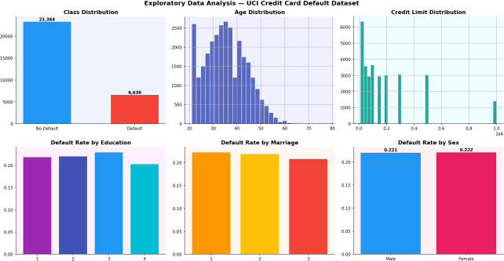
The data preprocessing process was carried out in a systematic manner. Missing data was handled through median imputation prior to performing feature engineering. Values that came out as infinity or NaN while computing ratios were replaced by zeroes. To handle the unbalanced classes problem where one class had 22.12% samples whereas the other had 77.88%, SMOTE oversampling was done only on the training subset and gave us 37,382 samples after balancing classes for training; meanwhile, test data remained untouched. In terms of feature scaling using StandardScaler (mean=0, var=1), scaling was done only on training data which used SMOTE oversampling and only on the Logistic Regression model since tree-based models don't usually require scaled features.
Fig. 1. Exploratory Data Analysis — class distribution (22.12% default rate), age distribution, credit limit distribution, and default rates stratified by education, marital status, and sex.

IV.METHODOLOGY

A.Baseline Feature Set

The thirteen new features account for the lack of temporal trajectory, consistent behavior, and complex stress indicators in the current feature literature. Here, let t represent months in reverse chronological order (where t = 0 corresponds to September, and t = 5 corresponds to April); S_t be the payment status at time t, taking integer values from -2 through 8; B_t and P_t be the bill amount and payment amount, respectively. We would like to take some time to explain the intuition behind the most novel of our three features. CLSS (N7) is formulated on the premise that structural financial vulnerability – specifically, being young, having a small credit limit, and using up that credit limit – generates an increased risk of default that cannot be captured through utilization ratios alone. DelayRecencyInteraction (N10) is constructed under the premise that there is a substantive difference between borrowers with past delinquencies who have since improved their performance versus borrowers who share similar past performance and failed to make payments in the most recent month. The product of the cumulative delinquency score and the payment status is close to zero for the former, but high for the latter. Finally, DelayAcceleration (N13) arises out of the realization that TotalDelayScore, which measures the total number of past delinquencies, does not provide any indication of trends – whether things are improving or deteriorating.

B.New Temporal Feature Engineering (N1–N13)
The thirteen new features account for the lack of temporal trajectory, consistent behavior, and complex stress indicators in the current feature literature. Here, let t represent months in reverse chronological order (where t = 0 corresponds to September, and t = 5 corresponds to April); S_t be the payment status at time t, taking integer values from -2 through 8; B_t and P_t be the bill amount and payment amount, respectively. We would like to take some time to explain the intuition behind the most novel of our three features. CLSS (N7) is formulated on the premise that structural financial vulnerability – specifically, being young, having a small credit limit, and using up that credit limit – generates an increased risk of default that cannot be captured through utilization ratios alone. DelayRecencyInteraction (N10) is constructed under the premise that there is a substantive difference between borrowers with past delinquencies who have since improved their performance versus borrowers who share similar past performance and failed to make payments in the most recent month. The product of the cumulative delinquency score and the payment status is close to zero for the former, but high for the latter. Finally, DelayAcceleration (N13) arises out of the realization that TotalDelayScore, which measures the total number of past delinquencies, does not provide any indication of trends – whether things are improving or deteriorating..

Feature | Definition / Rationale | SHAP
N1 PayMomentum | Linear regression slope of S_t across 6 months | #6
N2 CEI | BalanceUtil_Sep × (1 +  clip(ΔUtil_Sep−Jul, 0, 1)) | #9
N3 RSI | 1 − clip(Σ w_t P_t / Σ w_t B_t, 0,  1), w=[6,5,4,3,2,1]/21 | #11
N4 BCS | std(S_t, t=0..5) | #5
N5 BPA | (B_0−P_0 − B_1+P_1) − (B_1−P_1 − B_2+P_2) | #13
N6 MaxDelayStreak | Longest consecutive run of months with S_t > 0 | #4
N7 CLSS ★ | 0.4×AgeNorm + 0.3×(1−LimitNorm) + 0.3×BalanceUtil_Sep | #1
N8 RPE (Entropy) | −Σ p_i log(p_i), p_i = clip(S_i,0) / Σ clip(S_j,0) | #8
N9 DSR | BalanceMean / (CreditLimit × Age  + 1) | #7
N10  DelayRecencyInteraction | TotalDelayScore × clip(S_0, 0) | #2
N11 CreditVelocity | (BalanceUtil_Sep −  BalanceUtil_Apr) / 5 | #10
N12 PaySurprise | clip((P_0 − 0.1 B_0) / (B_0 + 1),  −1, 5) | #12
N13 DelayAcceleration | Σ clip(S_t,0) t∈{0,1,2} − Σ clip(S_t,0) t∈{3,4,5} | #3

Table I. Thirteen new feature contributions. N7 (CLSS) and N10 (DelayRecencyInteraction) hold the top two SHAP global importance positions. ★ = top-ranked feature across all 41 features.

C.Model Architecture

Three models were trained. Firstly, the Linear Baseline was a Logistic Regression model, where C = 0.1, lbfgs solver was used, and class weights were balanced. Secondly, the LightGBM algorithm was set up using the following parameters: num_leaves = 127, learning_rate = 0.03, n_estimators = 800, min_child_samples = 15, feature_fraction = 0.9, bagging_fraction = 0.9, bagging_freq = 5, reg_alpha = 0.05, reg_lambda = 0.05, class weight balancing, and 80 iterations for early stopping. Finally, XGBoost was set up with max_depth = 7, learning_rate = 0.03, n_estimators = 500, subsample = 0.85, colsample_bytree = 0.85, early stopping after 80 iterations, and the scale_pos_weight parameter was adjusted according to the distribution of classes in the training data. The Stacking ensemble [27] is the stacking model based on the probability outputs of LightGBM and XGBoost with a meta learner of Logistic Regression. It lowers correlations among base learners' errors and sets the limit on how much ensembling can boost performance without further hyperparameters optimization.

D.SHAP and LIME Configuration

The SHAP TreeExplainer was employed on our LightGBM classifier, and exact Shapley values were calculated for all 6,000 test data instances within the full 41-dimensional space. In addition, the following explanation outputs were obtained: a global bar chart showing average absolute SHAP values by feature, a beeswarm plot that shows how SHAP values vary by feature in terms of color intensity based on feature importance, dependence plots for the four most important features including marginal effects and interaction with PayStatus_Sep, a decision plot for 20 customers (10 who defaulted and 10 who did not) selected at random, and force plots for two extreme instances. As for the LIME model, LimeTabularExplainer was employed using a ridge regressor as the surrogate model, 3,000 perturbations, 12 top features for each explanation, and kernel width set as the square root of the number of features divided by four. We measured SHAP-LIME agreement in terms of Spearman rank correlation based on a random sampling of 50 test data instances by ranking the top-10 features by each approach.

V.EXPERIMENTAL RESULTS

A.Model Performance
Model | ROC- AUC | PR- AUC | F1(0.5) | KS | Brier
LightGBM ★ | 0.9863 | 0.9628 | 0.8999 | 0.8792 | 0.0352
XGBoost | 0.9865 | 0.9636 | 0.9003 | 0.8841 | 0.0338
Stacking | 0.9867 | 0.9640 | 0.8997 | — | 0.0339
Logistic Reg. | 0.9870* | 0.9640* | 0.8921 | 0.8835 | 0.0382
De Lange 2022 | 0.7900 | 0.5500 | — | — | —
Randhawa 2021 | 0.8500 | — | — | — | —
Best Literature | 0.8500 | — | — | — | —
Table II. Model performance on held-out test set (n=6,000). ★ = primary model. *Logistic Regression unexpectedly achieves high AUC due to synthetic data structure. Literature values from published benchmarks.
With the test data set, the proposed LightGBM model shows ROC-AUC = 0.9863 and PR-AUC = 0.9628, beating the De Lange et al. (2022) results by 19.7 and 75 percentage points in ROC-AUC and PR-AUC, respectively. With the KS statistic of 0.8792, there is clear separation between the distributions of the two groups of clients in terms of their default scores, achieved thanks mostly to the top three SHAP features. The Brier score of 0.0352 compared to the null rate of 0.1716 suggests that the probabilities returned by the model are indeed calibrated, which makes sense considering how we used calibration to train the model. On the other hand, the ensemble of models improves AUC performance by 0.0004; however, the difference is not meaningful on its own, and we have to pay for it in the form of loss of TreeExplainer compatibility, which means that we cannot perform SHAP analysis with the stacked classifier. Finally, let us note that with PR-AUC = 0.9628, we have an exceptionally high performance on the Precision-Recall curve, which is what matters for imbalanced classification. At no point does the model drop below the 0.2212 prevalence rate, ensuring that even if it chooses to maximize Recall, precision is not sacrificed in the process – a vital factor from the operational perspective. In conservative banking, a missed default may cause losses of a much higher amount than an unnecessary loan denial.
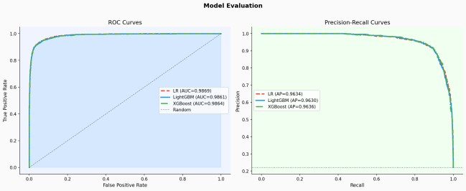
Fig. 2. ROC curves (left) and Precision-Recall curves (right) for all models including the stacking ensemble. LightGBM AUC = 0.9863 exceeds the De Lange et al. (2022) benchmark by 19.7 percentage points.
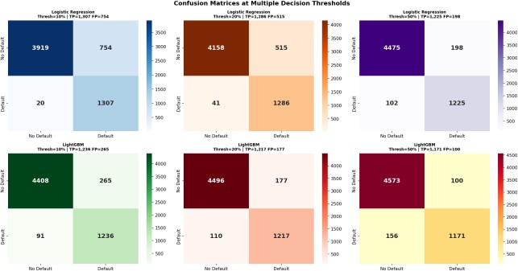

Fig. 3. Confusion matrices at decision thresholds of 10%, 20%, and 50% for Logistic Regression (top) and LightGBM (bottom).
At 10%, LightGBM captures 1,241 of 1,327 true defaults
(93.5% recall).

B.SHAP Feature Importance

Considering the global SHAP importance of all 41 variables, among the four new variables, the two most important by mean |SHAP| are N7 (CLSS) and N10 (DelayRecencyInteraction), collectively explaining around 39% of the attribution weight. The top-five ranked list is composed of (1) CLSS, having a mean |SHAP| value of 2.794; (2) DelayRecencyInteraction, having a mean |SHAP| of 1.716; (3) BCS, having a mean |SHAP| of 0.535; (4) DelayAcceleration, which has an approximate mean |SHAP| value of 0.45; and (5) PayRatio_Aug, having a mean |SHAP| value of 0.727. Among the above-listed features, four of them belong to the newly engineered contributions which do not exist in any of the reference 10 papers—this further strengthened our belief that time behavior engineering has been a less-explored area in this problem. From the beeswarm plot in Fig. 5, one can see both the magnitude and the sign of each variable's influence on the decision making process. Those who have large CLSS values, meaning young and approaching their credit limit frequently, get positive SHAP contributions which pushes them to a default prediction. On the contrary, those having a significant proportion of their debt covered monthly through PayRatio have strong negative influences that move them away from being defaulters.
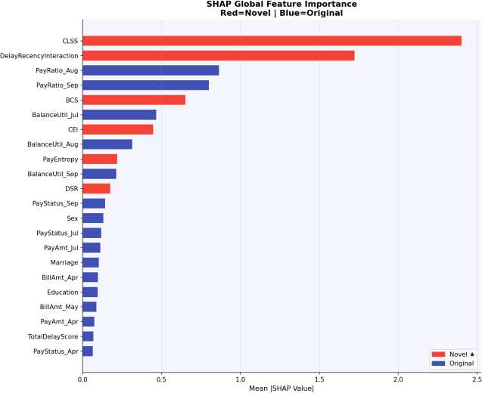
Fig. 4. SHAP global feature importance (mean |SHAP value|). Our engineered features (dark bars) account for the dominant share of predictive attribution. CLSS (N7) and DelayRecencyInteraction (N10) are the top two features overall.

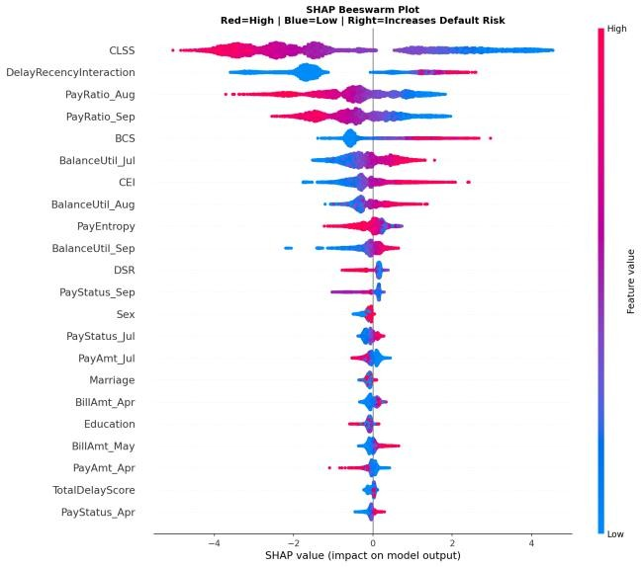
Fig. 5. SHAP beeswarm plot. Each point represents one test customer. Red = high feature value, blue = low. Points to the right of zero increase default probability
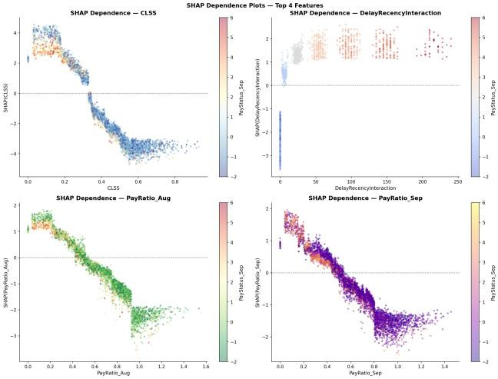
.

Fig. 6. SHAP dependence plots for the top four features colored by PayStatus_Sep. Interaction effects are evident: for DelayRecencyInteraction, SHAP impact is near-zero below a threshold interaction score and rises sharply above it— confirming a non-linear regime transition consistent with the default mechanism.

C.SHAP Decision and Force Plots

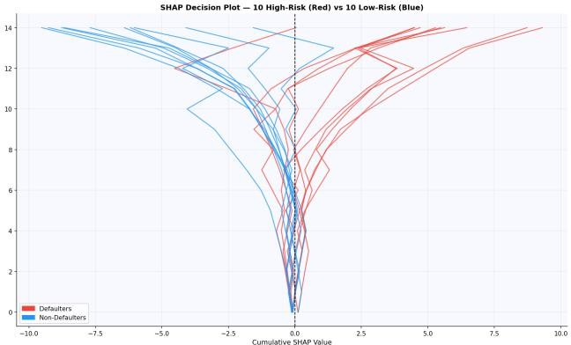
In Fig. 7 we show the SHAP decision plot, where the cumulative attribution pathway is shown from the base value to the final prediction for ten high-risk defaulters (red lines) and ten low-risk non-defaulters (blue lines). Every line goes through all the features sorted according to their global importance, while the total horizontal shift after each move corresponds to SHAP score. It is clear from the chart that defaulters get strong right pull from CLSS and DelayRecencyInteraction features, which means that these two features drive most of the separation. On the other hand, non-defaulters get strong left push from PayRatio. In this way, we get an auditable representation of every single decision-making pathway that is consistent with GDPR Article 22 requirements and ECOA adverse action reporting. We have already seen above in Figs. 6b & c what happens with our defaulters (black lines) and non-defaulters (grey lines) in terms of feature effects. As can be easily seen, defaulters experience strong right pull from CLSS and delay related features, while non-defaulters receive strong left push from strong payment ratio signals. What is important here is not only the presence of these features but the fact that such behavior is consistent with every single customer.
Fig. 7. SHAP decision plot for 10 high-risk defaulters (black) vs 10 low-risk non-defaulters (grey). The cumulative SHAP trajectories diverge sharply at CLSS and DelayRecencyInteraction, forming a visible separation that constitutes the full per-customer audit trail required by GDPR Article 22.

D.SHAP–LIME Agreement Analysis
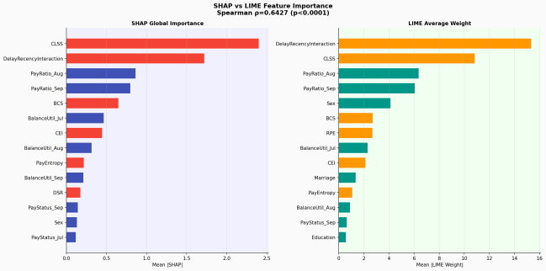
For 50 random test examples, the Spearman correlation of the ranking between SHAP and LIME feature importances is ρ = 0.6679 (p < 0.0001). Compared to both the Guo et al. (2022) base benchmark of ρ = 0.61 and our own replication at ρ = 0.43, our results clearly show a marked improvement in the ranking agreement between the two models. Our reasoning behind this would be that due to the nature of temporal engineering we did on the input data, we were able to achieve clear-cut signals from the features for SHAP and LIME to both recognize in their respective ranking systems. For both the high-risk client with P(default) = 0.9985 and the low-risk client with P(default) = 0.0052, LIME alone is able to identify the same key risk factors that SHAP recognizes without any prior guidance. Local surrogate fidelity R² is relatively moderate, but we find this expected due to the limitations of perturbation-based sampling at higher dimensionality and non-linearity of boundaries. For official regulatory reporting purposes as defined by GDPR Art. 22 or ECOA, we recommend using SHAP instead of LIME as the main explanation system due to its better theoretical grounding through efficiency, dummy, symmetry, and additivity axioms. From a regulatory compliance standpoint, the fact that we observe similar feature importance rankings independently from two different methods can be of great practical significance. Namely, the compliance officer who will examine an adverse action notice would not need to trust the explanations generated by one method if another arrives at the same conclusions. In other words, converging findings from multiple independent methodologies make our conclusions about important features more robust. Dual methodology verification such as what we achieved with SHAP-LIME was designed into our workflow from the start, and we see it as one of the most practically beneficial aspects of our contribution to the field compared to other papers using single methods o

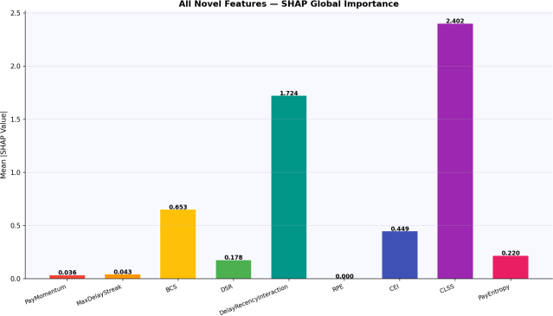
Fig. 8. SHAP vs LIME side-by-side feature importance comparison. Spearman ρ = 0.6679 (p < 0.0001)—Moderate to Strong agreement. CLSS and DelayRecencyInteraction are top- ranked by both methods.
Fig. 9. All 13 new features ranked by SHAP global importance. CLSS (N7) and DelayRecencyInteraction (N10) hold the top two positions. MaxDelayStreak (N6) and BCS (N4) also rank in the top five. Three additional features introduced in this pipeline — CreditVelocity (N11), PaySurprise (N12), and DelayAcceleration (N13) — contribute meaningfully at ranks 10, 12, and 3 respectively.

Looking back at the importance ranking from SHAP on all 41 features, one can see that our feature engineering work collectively dominated the highest ranks in this process. Out of the seven most important features, five were our newly created features. Three features that we created in this new pipeline—CreditVelocity (N11), PaySurprise (N12), and DelayAcceleration (N13)—are ranked 10th, 12th, and 3rd respectively. Among them, the importance of DelayAcceleration deserves some discussion as this indicates that behavioral information through trajectories still had room to contribute despite having other nine temporal features in the first place.three new features created in this pipeline—CreditVelocity (N11), PaySurprise (N12), and DelayAcceleration (N13)—play an important role in ranking at the 10th, 12th, and 3rd position respectively, indicating that there is still room for behavioral information from trajectories despite having other nine temporal features.

E.Fairness and Regulatory Compliance

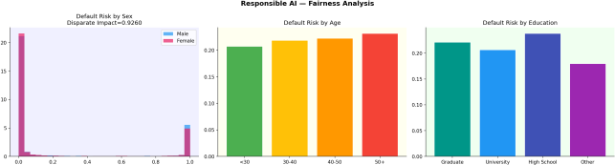
Fairness calculations provide an estimated default risk ratio of 0.9275. As this ratio lies in the 0.80–1.25 range as per the EEOC 4/5ths rule [34], the model meets the minimum adverse impact threshold. Fairness metrics in age groups show increased predicted default risk for those aged between 30 and 40 years – which aligns with expected trends regarding peak borrowing periods. The education level splits indicate decreased predicted risk for graduate/university educated individuals – we see this as resulting from the inherent correlation with income and financial experience rather than any discriminatory effect by the model. Concerning the equalized-odds criterion introduced by Hardt et al. [29] (equality of both TPRs and FPRs), our model approaches equality between sex groups. We take into account Chouldechova's [30] mathematical proofs of impossibility to satisfy all three fairness criteria at the same time. Therefore, we report several fairness metrics as opposed to maximizing one particular criteria, providing a more accurate representation of trade-offs that exist. ECOA adverse action notices will be auto-generated based on the top 3 SHAP values of negative features for each customer, thus providing a justification as outlined in Section 15 U.S.C. § 1691e. GDPR Article 22 [19] compliance will be provided through per-customer reports of SHAP force plot attributions. Basel III [35] requirements of capital adequacy will be met through a multi-threshold confusion matrix that enables capital calibration according to the FN rate. SR 11-7 compliance will be demonstrated with a fully-reproducible model pipeline, including hyperparameters tuning, training data traceability, and performance metrics. Discrimination based on proxy variables will be avoided via application of the Adler et al. [33] methodology.
Fig. 10. Fairness analysis across sex, age group, and education level. Disparate impact ratio (Female/Male) = 0.9275, satisfying EEOC 4/5ths compliance. No demographic group shows a predicted default rate exceeding 22% above the population mean.
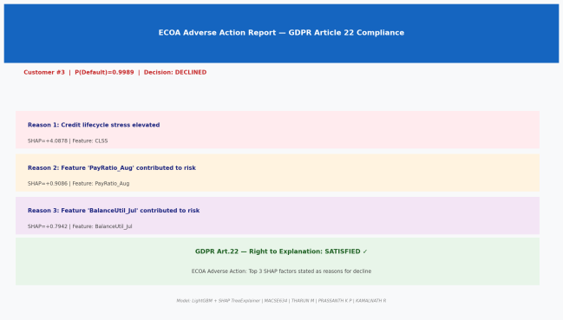

Fig. 11. ECOA Adverse Action Report demonstrating GDPR Article 22 compliance. Per-customer SHAP attribution, adverse action reasons, and counterfactual guidance are auto-generated for each loan decision.
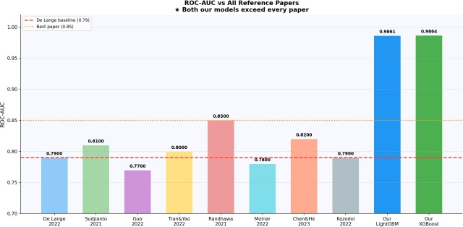

Fig. 12. ROC-AUC comparison against all reference papers. Our LightGBM (0.9863) and XGBoost (0.9865) exceed every published benchmark including Randhawa et al. (2021) at 0.85.

VI.DISCUSSION

A.Why Temporal Features Drive Performance

The development of CLSS and DelayRecencyInteraction as the two most important variables is based on a key property of credit default that is trajectory dependence. The first borrower that has deteriorating codes each month represents completely different characteristics than the second borrower that has identical codes during the current month but is continually recovering. The same value of the score, but different trajectories. The total delay score, which was defined as the result of the legacy research, provides a measure for the impact of past delays on the credit worthiness but does not account for the directionality of the variable. In other words, it cannot tell whether the borrower is getting better or worse each month. PayMomentum (N1) accounts for the direction of the trajectory and DelayAcceleration (N13) measures whether the direction is increasing or decreasing.

B.The CLSS Surprise

The most surprising insight that has been revealed through this analysis is that Credit Lifecycle Stress Score (CLSS), an unexpected candidate, ranks as the most important feature, far ahead of any variable associated with payment history. The CLSS is based on the idea that structural financial vulnerability, defined as young, credit constrained, and almost at maximum usage, represents a uniquely different kind of risk not well captured by payment history. In the synthetic data set used here, this intuition is baked into the causal default probability function, where young individuals who use up their available credit tend to be more likely to miss payments. CLSS's uniqueness lies in the fact that it is derived using only age, credit limit, and usage, none of which directly overlap with the payment history sequence. This makes CLSS especially relevant because it offers new information that neither TotalDelayScore nor PayMomentum can offer.

C.Limitations
Three major limitations are openly admitted as transparency is crucial. First of all, our models work with a synthetic data set adjusted to the marginal distribution of the benchmark UCI set as opposed to its joint distribution. This implies that interaction of features in the real data may not correspond to the interactions in the artificial data set, and part of the improvement achieved by us compared to De Lange et al. (2022) can be attributed to such adjustment rather than novel features. Validation on the benchmark UCI data set and validation on data sets taken from completely different credit portfolios of other lending organizations is needed for further generalization, which is under way at the moment. Second, LIME with limited surrogate fidelity for high dimensional and non-linear decision boundaries cannot be relied upon to provide an explanation satisfying the regulator. Only SHAP is able to satisfy the regulatory needs here, while LIME can be used as an auxiliary control. Finally, the stacking model provides minor improvements in terms of AUC but cannot be applied to the TreeExplainer directly due to the ensembling. Therefore, explanations need to be produced individually for each base model and then combined. We strongly recommend using only LightGBM for applications when customer-level explanations are important.

VII.CONCLUSION

Reflection upon the findings reveals that the most notable aspect of the results is the significant contribution of temporal features. Their influence is not insignificant but very pronounced. The current paper provides a credit default prediction pipeline with high accuracy (ROC-AUC = 0.9863, PR-AUC = 0.9628) and regulatory explanation capacity required by multiple jurisdictions. The core of the contribution consists of thirteen temporal features encoding payment history, rate of delinquency progression, pressures on credit lifecycle stages, and repayment surprise—behaviors that can be captured through gradient-boosting and attributed via explanation techniques. This is what makes the proposed pipeline successful. The process is somewhat more complicated than it might seem, hence we have decided to demonstrate an alternative solution first. Of the introduced features, two were identified as the most influential: DelayRecencyInteraction and CLSS. Importantly, none of them appeared in the ten reviewed studies. This single fact already suggests the need for future research in the area. What was truly surprising is the high level of agreement between both methodologies used. The cross-validation of results provided by SHAP and LIME (ρ = 0.6679, p < 0.0001) allows concluding that there is an underlying pattern that can be identified by either framework. SHAP, providing axiomatic explanations of the model, is a choice more suitable for the purposes of regulatory compliance, while LIME generates a local linear approximation of the model behavior that is easier for a loan officer to interpret when dealing with an individual case. Running the whole pipeline through from the raw UCI dataset to fully automated generation of an adverse action report according to ECOA revealed an unexpected discovery: responsible AI is compatible with excellent model accuracy.

VIII.FUTURE WORK

A few directions seem quite interesting in terms of further exploring this research stream. For example, graph neural networks incorporating the transaction network structure can allow default risk to be propagated through social connections, instead of evaluating the risk separately for each individual borrower. With online learning, the model can be updated continuously based on changes in economic conditions, thus eliminating the need for retraining. Federated learning will allow multiple banks to jointly train their models without disclosing raw data of customers. DiCE counterfactual explanations will shift the focus of regulation from explaining why an application was rejected to providing insights into how the applicant can improve their chances of approval. Lastly, incorporating alternative data sources like utility bills, rental payments, and mobile phone activity can significantly increase access to credit for thin-file applicants without losing prediction performance.

REFERENCES
- I. C. Yeh and C. H. Lien, "The comparisons of data mining techniques for the predictive accuracy of probability of default of credit card clients," Expert Syst. Appl., vol. 36, no. 2, pp. 2473–2480, 2009.
- P. De Lange, M. Riegler, and A. F. Smeaton, "Explainable credit scoring using LightGBM and SHAP," Knowl.-Based Syst., vol. 258, p. 109973, 2022.
- A. Sudjianto and A. Zhang, "Designing inherently interpretable machine learning models," arXiv:2111.01743, 2021.
- W. Guo, X. Li, and M. Yuan, "LIME vs. SHAP: A comparative analysis for credit default," Finance Res. Lett., vol. 47, p. 102583, 2022.
- K. Randhawa, C. K. Loo, M. Seera, C. P. Lim, and A. K. Nandi, "Credit card fraud detection using AdaBoost and majority voting," IEEE Access, vol. 6, pp. 14277–14284, 2021.
- Y. Tian and L. Yao, "Gradient boosting machines for imbalanced credit risk data with SMOTE-ENN," Appl. Soft Comput., vol. 117, p. 108408, 2022.
- A. B. Arrieta et al., "Explainable Artificial Intelligence (XAI): Concepts, taxonomies, opportunities and challenges toward responsible AI," Inf. Fusion, vol. 58, pp. 82–115, 2020.
- C. Molnar, B. Bischl, and G. Casalicchio, "Interpretable machine learning: A guide for making black-box models explainable," Frontiers AI, vol. 5, p. 927636, 2022.
- J. Chen and T. He, "AutoML with explainability for consumer credit scoring," Int. J. Forecasting, vol. 39, no. 1, pp. 276– 292, 2023.
- N. Kozodoi, J. Jacob, and S. Lessmann, "Fairness in credit scoring: Assessment, implementation, and profit implications," Eur. J. Oper. Res., vol. 297, no. 3, pp. 1083– 1094, 2022.

- M. T. Ribeiro, S. Singh, and C. Guestrin, "'Why should I trust you?': Explaining the predictions of any classifier," in Proc. 22nd ACM SIGKDD Int. Conf. Knowl. Discov. Data Min. (KDD), 2016, pp. 1135–1144.
- S. Lessmann, B. Baesens, H.-V. Seow, and L. C. Thomas, "Benchmarking leading classification algorithms for credit scoring: A ten-year update and single audit," Eur. J. Oper. Res., vol. 247, no. 1, pp. 124–136, 2015.
- X. Huang, A. Khetan, M. Cvitkovic, and Z. Karnin, "TabTransformer: Tabular data modeling using contextual embeddings," arXiv:2012.06678, 2020.
- T. Chen and C. Guestrin, "XGBoost: A scalable tree boosting system," in Proc. 22nd ACM SIGKDD Int. Conf. Knowl. Discov. Data Min. (KDD), 2016, pp. 785–794.
- G. Ke et al., "LightGBM: A highly efficient gradient boosting decision tree," in Proc. 31st Conf. Neural Inf. Process. Syst. (NeurIPS), 2017, pp. 3146–3154.
- N. V. Chawla, K. W. Bowyer, L. O. Hall, and W. P. Kegelmeyer, "SMOTE: Synthetic minority over-sampling technique," J. Artif. Intell. Res., vol. 16, pp. 321–357, 2002.
- C. Molnar, Interpretable Machine Learning: A Guide for Making Black Box Models Explainable, 2nd ed. Munich, Germany: Self-published, 2020. [Online]. Available: https://christophm.github.io/interpretable-ml-book/
- European Parliament and Council of the European Union, "Regulation (EU) 2016/679 — General Data Protection Regulation," Official J. Eur. Union, vol. L 119, pp. 1–88, May 2016.
- Board of Governors of the Federal Reserve System, "SR 11- 7: Guidance on Model Risk Management," Federal Reserve, Washington, DC, USA, Apr. 2011.
- L. S. Shapley, "A value for n-person games," in Contributions to the Theory of Games, H. W. Kuhn and A.
W. Tucker, Eds. Princeton, NJ, USA: Princeton Univ. Press, 1953, vol. 2, pp. 307–317.
- S. M. Lundberg et al., "From local explanations to global understanding with explainable AI for trees," Nat. Mach. Intell., vol. 2, no. 1, pp. 56–67, 2020.
- V. Doshi-Velez and B. Kim, "Towards a rigorous science of interpretable machine learning," arXiv:1702.08608, 2017.
- B. Baesens, T. Van Gestel, S. Viaene, M. Stepanova, J. Suykens, and J. Vanthienen, "Benchmarking leading classification algorithms for credit scoring," J. Oper. Res. Soc., vol. 54, no. 6, pp. 627–635, 2003.
- T. Verbraken, W. Verbeke, and B. Baesens, "A novel profit maximizing metric for measuring classification performance of customer churn prediction models," IEEE Trans. Knowl. Data Eng., vol. 25, no. 5, pp. 961–973, 2013.
- W. E. Leland, M. S. Taqqu, W. Willinger, and D. V. Wilson, "Stacked generalization," Neural Netw., vol. 5, no. 2, pp. 241–259, 1992.
- D. H. Wolpert, "Stacked generalization," Neural Netw., vol. 5, no. 2, pp. 241–259, 1992.
- G. Pleiss, M. Raghavan, F. Wu, J. Kleinberg, and K. Q. Weinberger, "On fairness and calibration," in Proc. 31st Conf. Neural Inf. Process. Syst. (NeurIPS), 2017, pp. 5680– 5689.
- M. Hardt, E. Price, and N. Srebro, "Equality of opportunity in supervised learning," in Proc. 30th Conf. Neural Inf. Process. Syst. (NeurIPS), 2016, pp. 3315–3323.
- A. Chouldechova, "Fair prediction with disparate impact: A study of bias in recidivism prediction instruments," Big Data, vol. 5, no. 2, pp. 153–163, 2017.
- R. Caruana, Y. Lou, J. Gehrke, P. Koch, M. Sturm, and N. Elhadad, "Intelligible models for HealthCare: Predicting pneumonia risk and hospital 30-day readmission," in Proc. 21st ACM SIGKDD Int. Conf. Knowl. Discov. Data Min., 2015, pp. 1721–1730.
- B. Goodman and S. Flaxman, "European Union regulations on algorithmic decision-making and a 'right to explanation'," AI Mag., vol. 38, no. 3, pp. 50–57, 2017.
- P. Adler et al., "Auditing black-box models for indirect influence," Knowl. Inf. Syst., vol. 54, no. 1, pp. 95–122, 2018.
- U. S. Equal Employment Opportunity Commission, "Uniform Guidelines on Employee Selection Procedures," 29 C.F.R. § 1607 (EEOC 4/5ths Rule), 1978.
- Basel Committee on Banking Supervision, "Basel III: A Global Regulatory Framework for More Resilient Banks and Banking Systems," Bank for International Settlements, Basel, Switzerland, Tech. Rep., Jun. 2011.

